FINAL REPORT - INFORMATION BASED CHATBOT

# 

# BY:

# Asha (9352)

# Shaikh Mubashir Akhtar (9310)

**Table of content**

1 . Introduction 3

1. Description 3
2. Machine Learning and Deep Learning in AI chatbots 3
3. Algorithm used in ChatBot 4
4. NLP(Natural Language Processing): 4
5. Artificially Intelligent Chatbots 5
6. Our Project 5

7.1. Login Page

7.2. Sign Up Page

7.3. Main Page

7.4. Friend Request Page

7.5. Chat Detail Page

7.6. Profile Page

# Introduction

Our names are Shaikh Mubashir Akhtar and Asha, we are final-year students. We think AI as a field is very interesting and are looking forward to having a lot of professional discussions about the topic through our project work. We are making our own Chat application with the functionality of **Chat BOT**. In this application user can sign In with his/her Cell number or Email ID and can start using our application. We will make the application user friendly and for security purpose we will make the user to login with Email as well. User can make group Chat and share everything in it.

1. **Description**

Chatbots are software applications that use artificial intelligence & natural language processing to understand what a human wants, and guides them to their desired outcome with as little work for the end user as possible. Like a virtual assistant for your customer experience touch points. The adoption of chatbots was accelerated in 2016 when Facebook opened up its developer platform and showed the world what is possible with chatbots through their Messenger app. Google also got in the game soon after with Google Assistant. Since then there have been a tremendous amount of chatbot apps built on websites, in applications, on social media, for customer support, and countless other examples.

# Machine Learning and Deep Learning in AI chatbots:

Machine learning is used to describe how a computer can receive data, analyze and interpret that data to identify certain patterns, and then use that analysis to make the best logical decisions without input from a human operator. A chatbot learns simply by recognizing repetitive patterns during conversations it has with humans combined with pre-determined chat scripts and a database of answers for responses. The more the program operates, the more it “learns” from the database and the more intelligent the chatbot becomes.

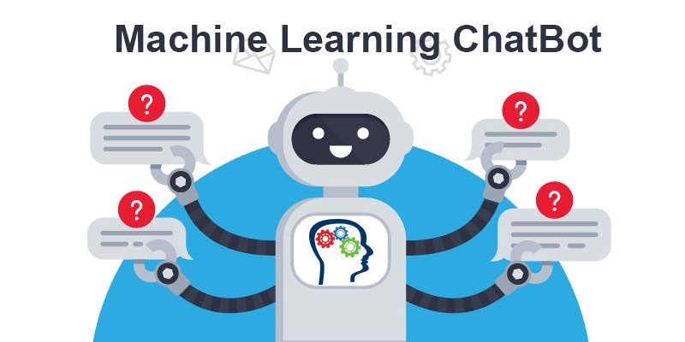

# Algorithm used in ChatBot:

# If the word “chatbot” conjures memories of frustrating and unnatural conversations, worry not. The chatbots of today are sleek and sophisticated. In fact, with machine learning technology, they can even feel human. The chatbots not only provide a better user experience, they also help human agents by taking over repetitive and time consuming communications. This frees up the human agent to concentrate on those more complex cases that require human input. But how does this all work? Understanding how your NLP text-based chatbot operates will help you ensure it stays on track as it goes to serve your company.

# 

# What is NLP(Natural Language Processing):

# Natural Language Processing, or NLP for short, is broadly defined as the automatic manipulation of natural language, like speech and text, by software. Natural language refers to the way we, humans, communicate with each other. NLP is a branch of informatics, mathematical linguistics, machine learning, and artificial intelligence. NLP helps your chatbot to analyze the human language and generate the text. Let’s have a look at the core fields of Natural Language Processing.

# Artificial intelligence and machine learning algorithms to transform chatbots - Techiexpert.com

# Artificially Intelligent Chatbots:

These are based on NLP. Natural language processing for chatbot makes such bots very human-like. They react to the meaning of the whole question. The AI-based chatbot can learn from every interaction and expand their knowledge. An NLP based chatbot is a computer program or artificial intelligence that communicates with a customer via textual or sound methods. Such programs are often designed to support clients on websites or via phone. The chatbots are generally used in messaging applications like Slack, Facebook Messenger, or Telegram. They can order your food, buy tickets, or show the weather podcasts.

# Our Project:

Our project is a chat application in which we can send request and when the request is accepted we can chat with each other and can send videos and images. Once the user get logout the other user can send messages and also can get reply from the user who is logged out through chatbot.

# Login Page:

As you can see the picture below, the user will login to their account as it is linked with the database the details of users are stored in it. If the user is using this app first time then they have to simply sign up to their account and their details will be added into the data base.

# 

# 

# Sign Up page:

This is our sign up page. The user have to enter their email address, user name and password then click on register then their account will be added in the database.

# 

# C:\Users\Shaikh\Desktop\WhatsApp Image 2021-03-28 at 8.00.55 PM.jpeg

Once the user registered their account then their data will be stored in the database and next time when they login they have to just put their email address and password into the login page.

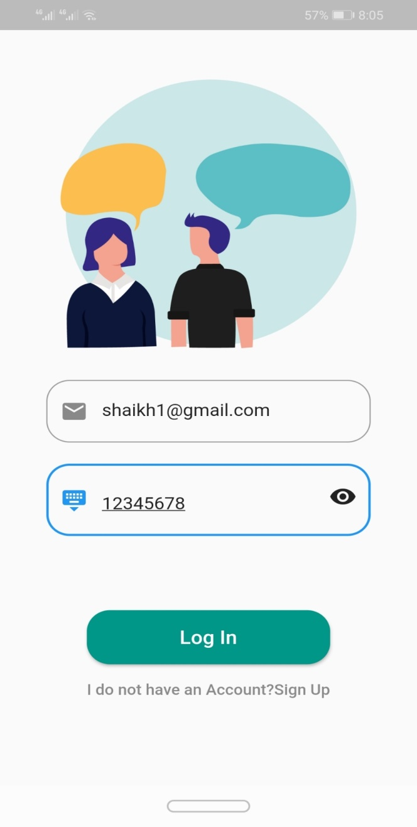

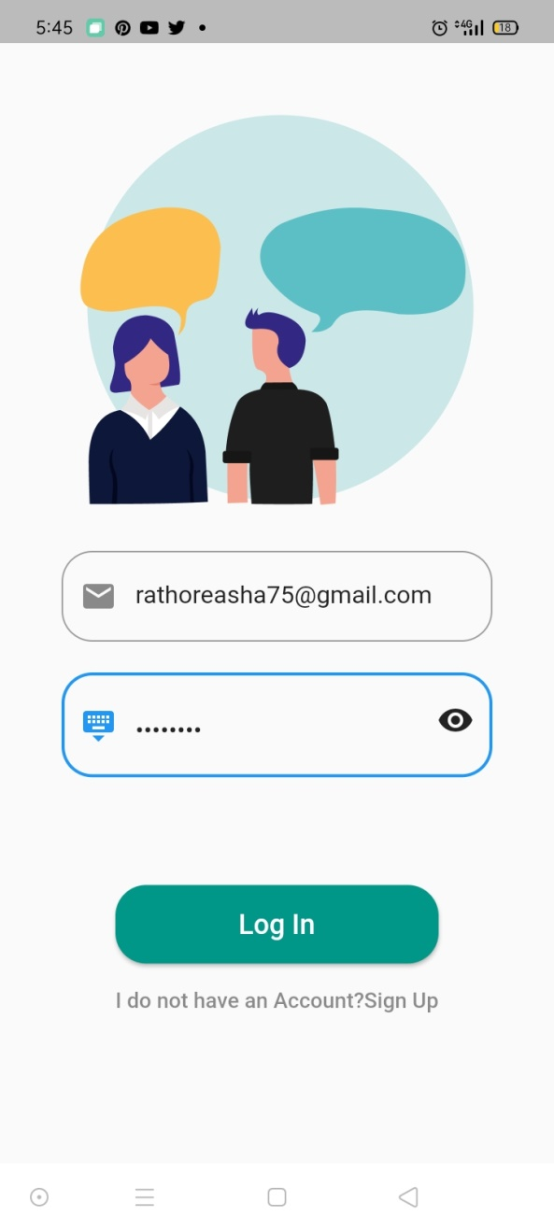

# 

# Main Page:

So this is our main page, here all the chats will appear, and chats will be saved as the user log out to their account.

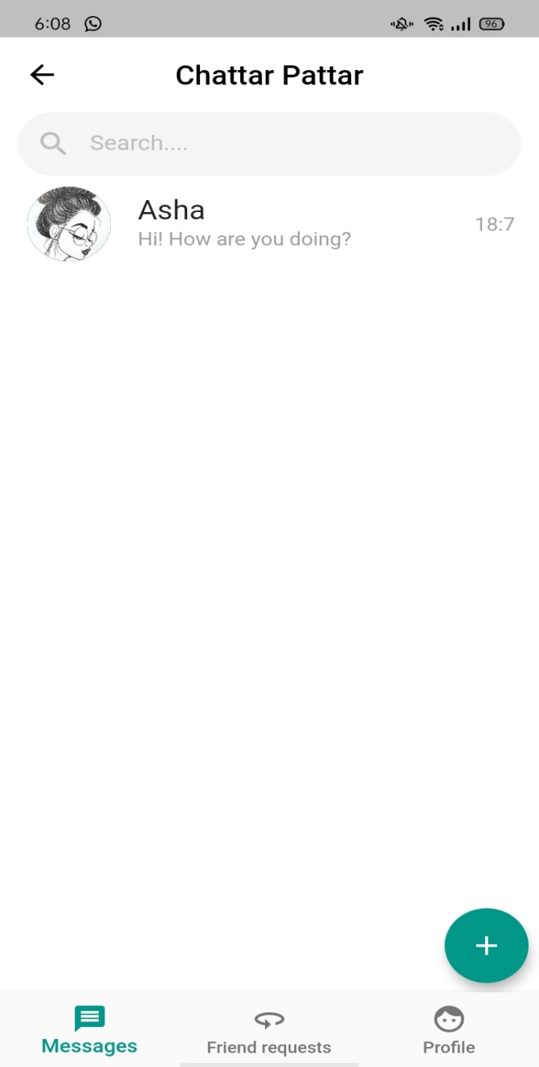

# Friend Request Page:

In this page the user will search another users and send them request like in snapchat we used to search people and send them request. Once the user accept request then they can chat with each other.

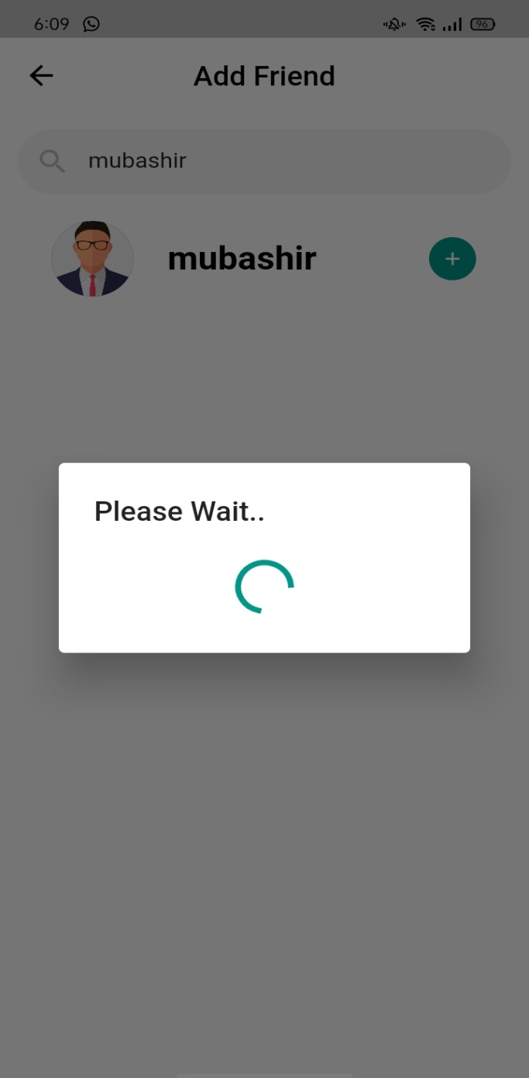

# 

# Chat Detail Page:

This is our chat page in this page we can send messages to each other and also as we discussed above that if the other user is logged out they can still chat with each other with the help of chatbot. If user1 send message to user2 which is logged out, the user1 still get reply from user2 through chatbot.

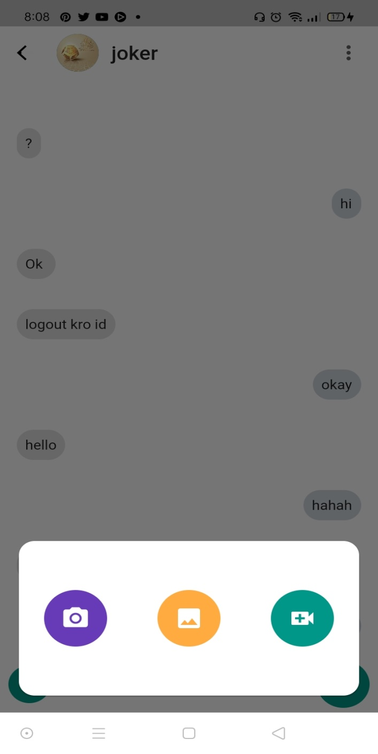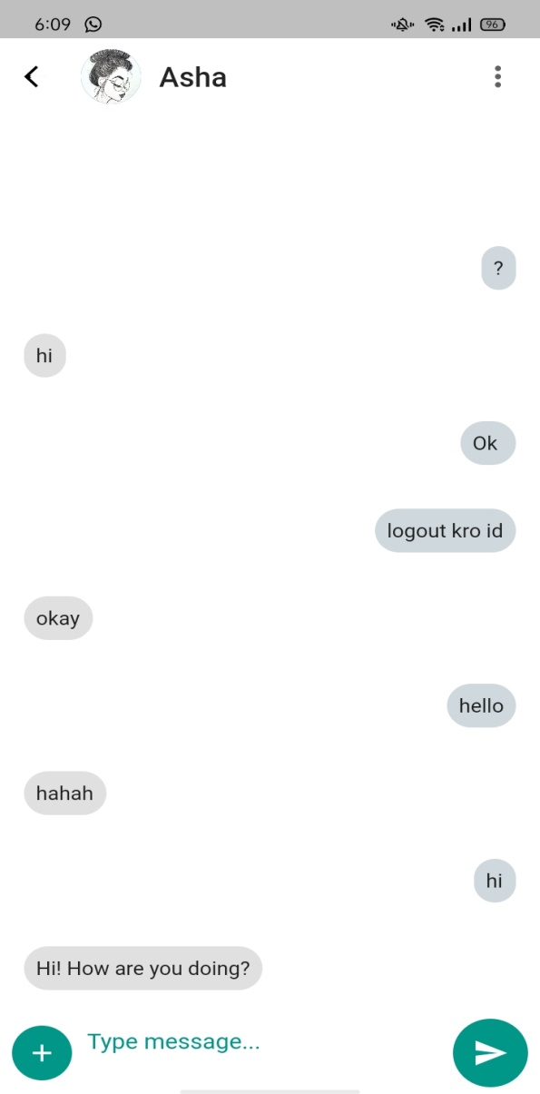

Also the user can share images and videos to each other.

These are the video and image screen pages.

# 

# Profile Page:

In last this is our profile page. The user name, email and profile picture will appear here. These are saved in database.

